AWS WAF

Task Title: AWS WAF with Application Load Balancer (IP-based access control)
Objective
To deploy an internet-facing Application Load Balancer backed by an EC2 instance and protect it using AWS WAF by creating a Web ACL with an IP set rule to block or allow traffic based on source IP address.
Prerequisites
• AWS account with required permissions (EC2, VPC, ELB, WAF)
• VPC with at least two subnets in different Availability Zones
• Internet Gateway attached to the VPC
• EC2 instance with web server installed
• Application Load Balancer and Target Group
• Known client IP address for WAF IP set testing
Step-by-Step Implementation (With Evidence)
Step 1: Create VPC
• Console path: VPC → Your VPCs → Create VPC
• Explanation: Created a custom VPC with IPv4 CIDR 10.0.0.0/24 to host all networking resources.
• Evidence: 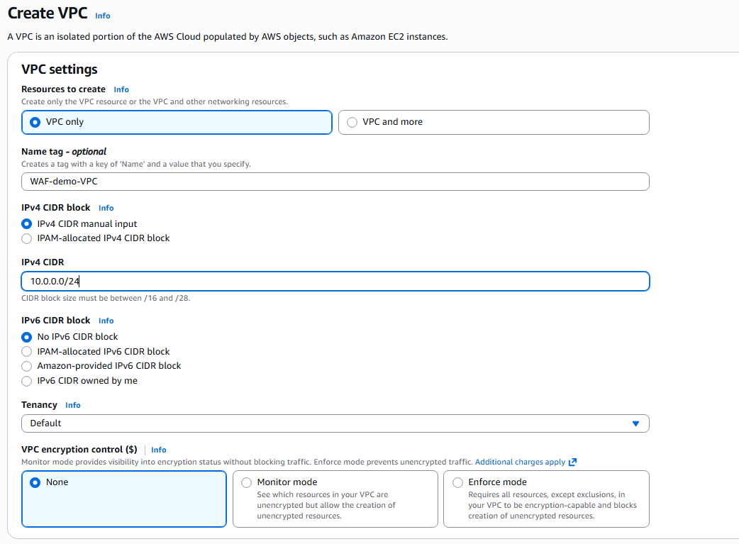
Step 2: Create and Attach Internet Gateway
• Console path: VPC → Internet Gateways → Create internet gateway → Attach to VPC
• Explanation: Internet Gateway enables internet access for public subnets.
• Evidence: 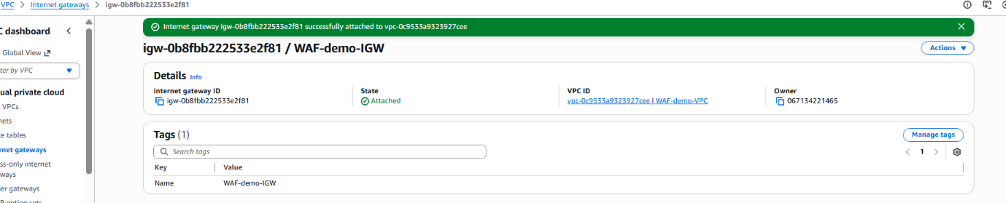
Step 3: Create Subnets in Multiple AZs
• Console path: VPC → Subnets → Create subnet
• Explanation: Created two subnets (10.0.0.0/26 and 10.0.0.64/26) in us-east-1a and us-east-1b for high availability.
• Evidence: 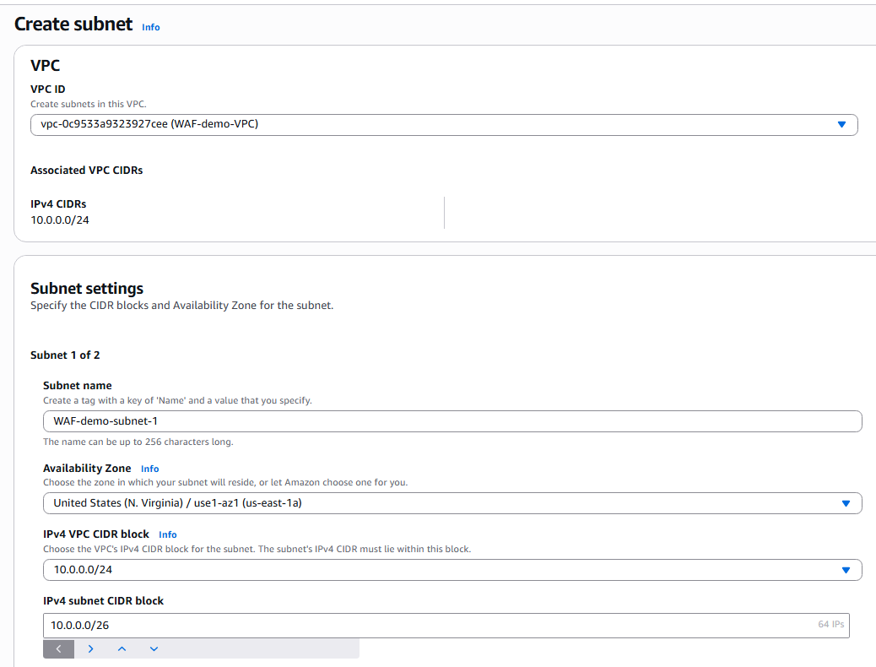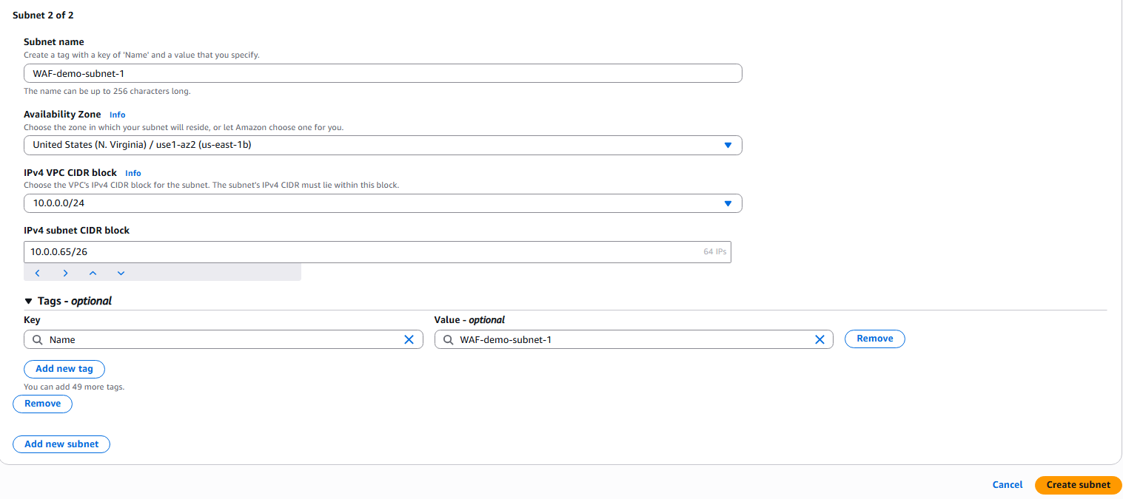
Step 4: Configure Route Tables
• Console path: VPC → Route Tables
• Explanation: Associated subnets with route tables and ensured local routing within VPC.
• Evidence: 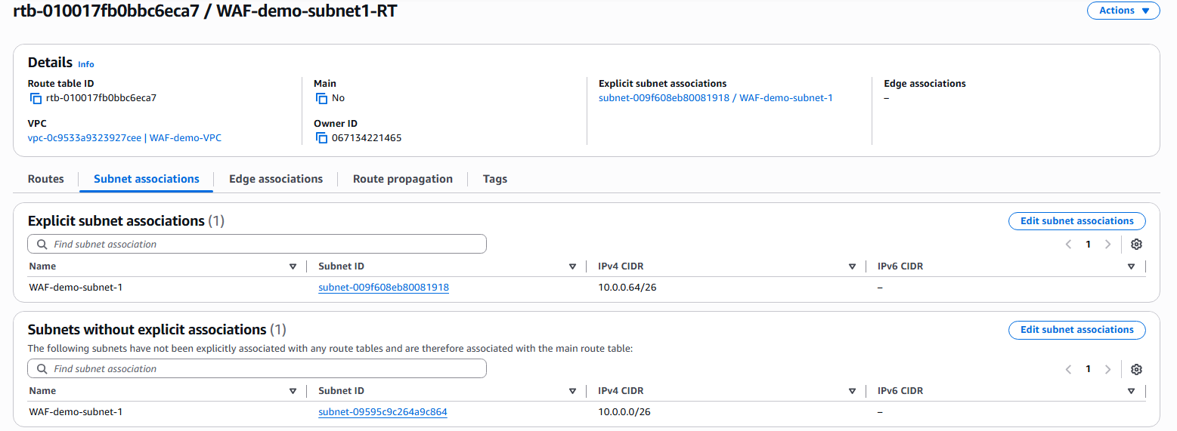
Step 5: Launch EC2 Instance
• Console path: EC2 → Instances → Launch instance
• Explanation: Launched Amazon Linux EC2 instance with HTTP and SSH access. User data installs Apache and serves a test page.
• Evidence: 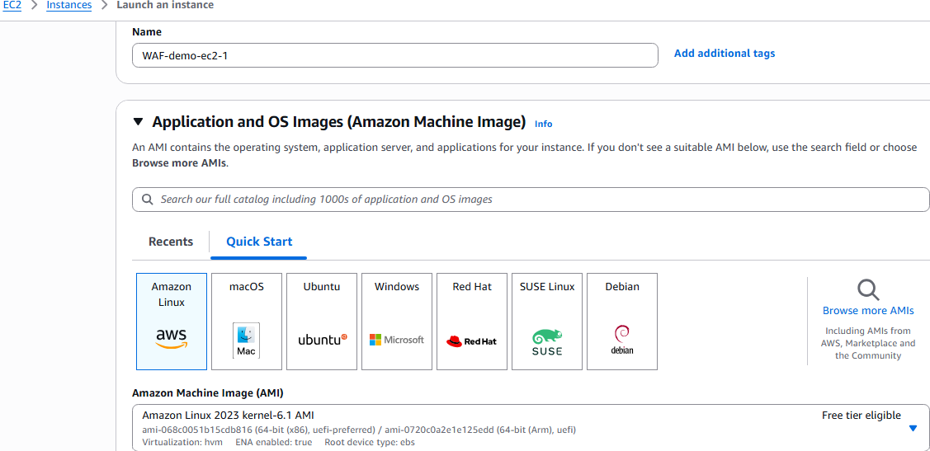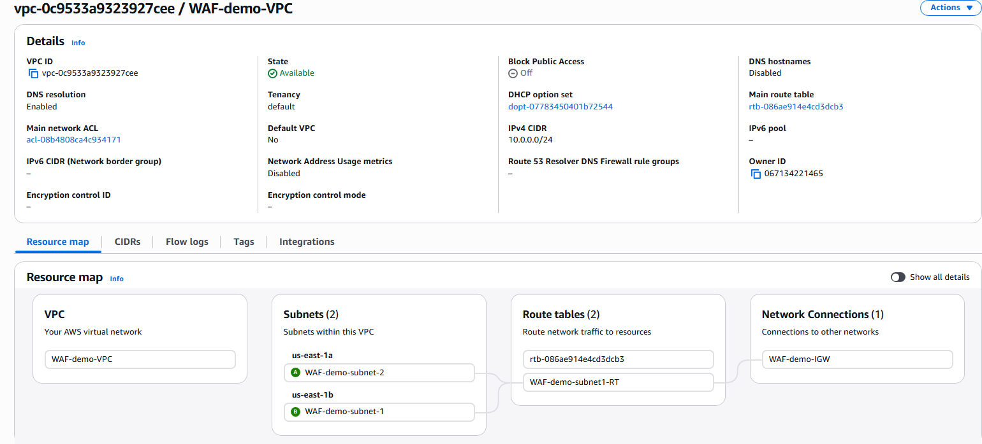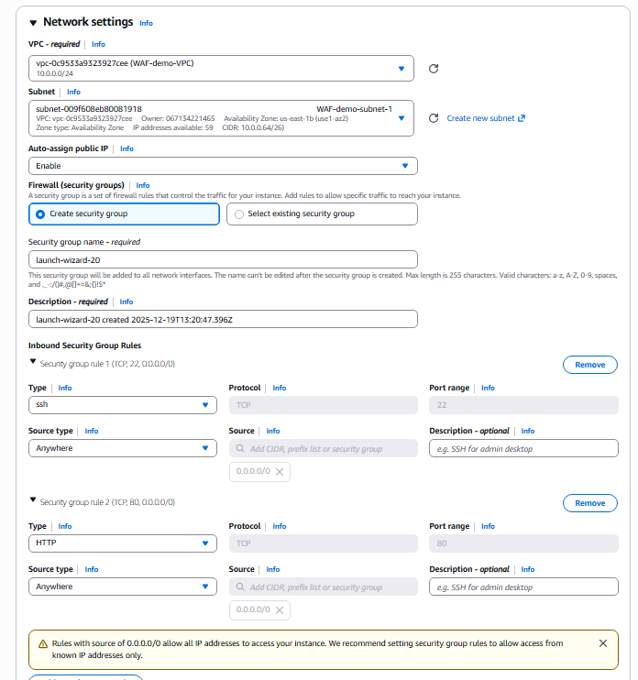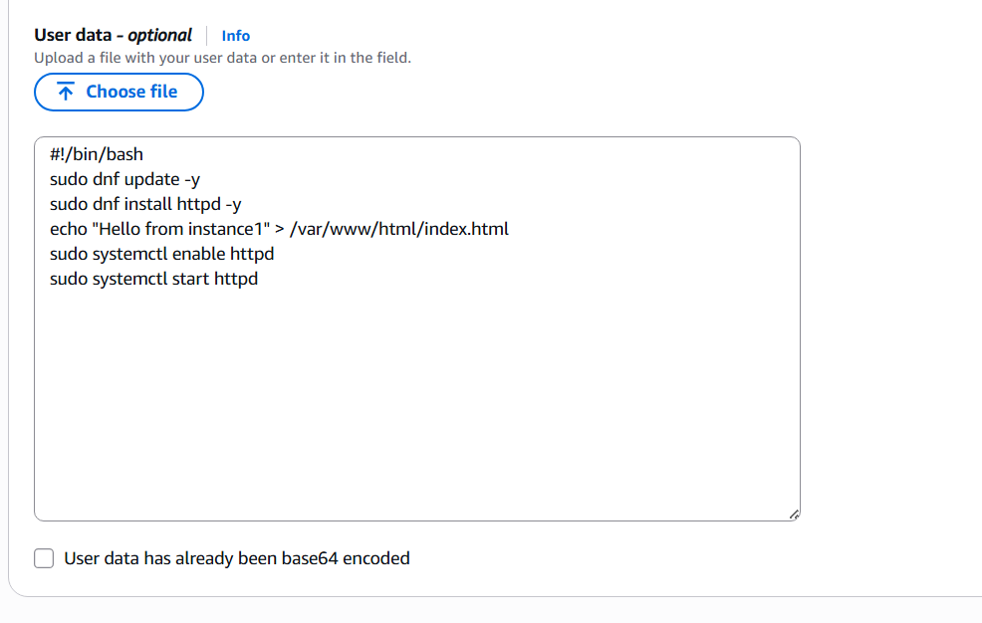
Step 6: Verify EC2 Instance
• Console path: EC2 → Instances → Instance ID
• Explanation: Confirmed instance is running with public IP assigned.
• Evidence: 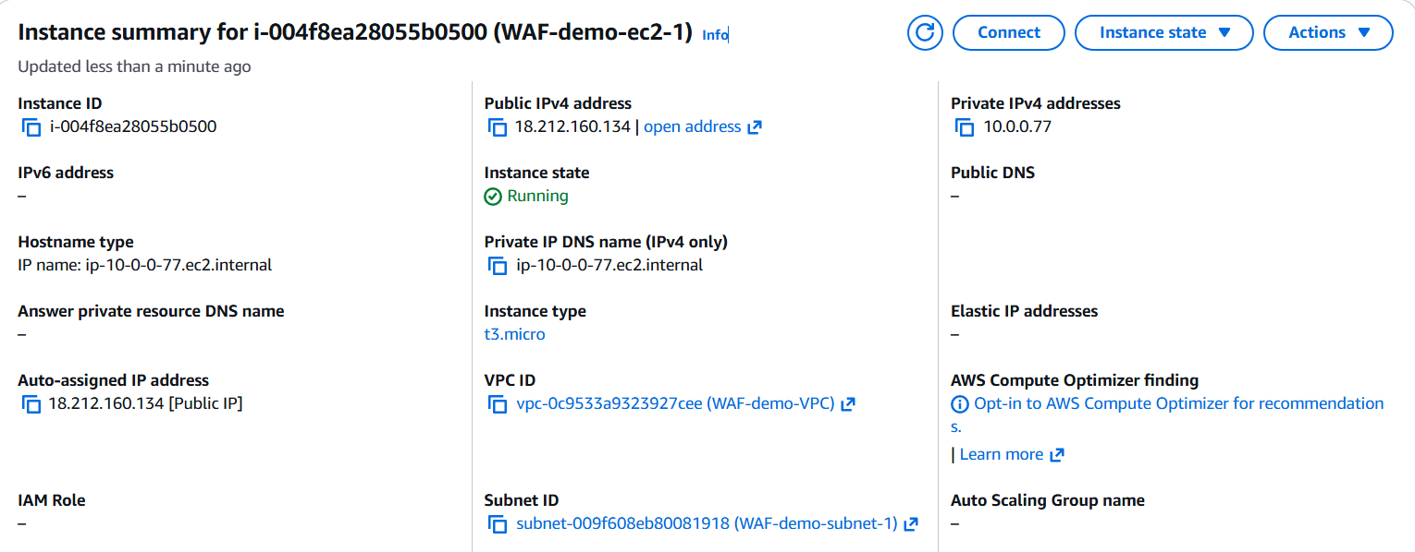
Step 7: Create Target Group
• Console path: EC2 → Target Groups → Create target group
• Explanation: Created HTTP target group on port 80 and registered EC2 instance.
• Evidence: 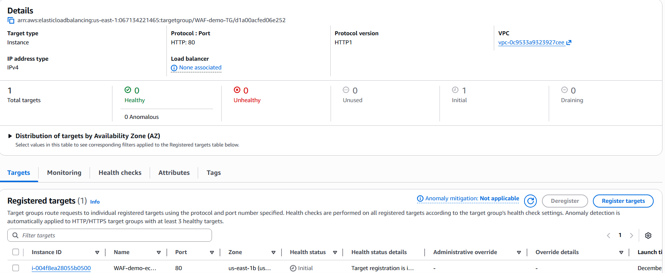
Step 8: Create Application Load Balancer
• Console path: EC2 → Load Balancers → Create load balancer
• Explanation: Created internet-facing ALB across two subnets and attached listener on HTTP:80 forwarding to target group.
• Evidence: 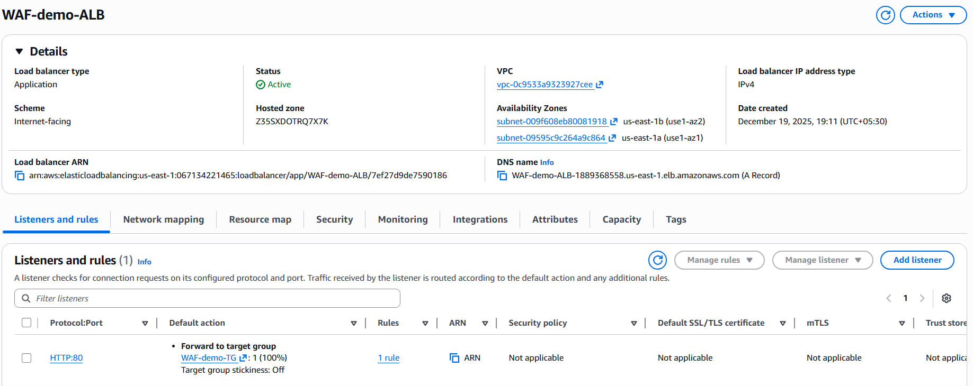
Step 9: Verify ALB Listener and Target Group Association
• Console path: EC2 → Load Balancers → Listeners
• Explanation: Confirmed traffic is forwarded to target group with 100% weight.
• Evidence: 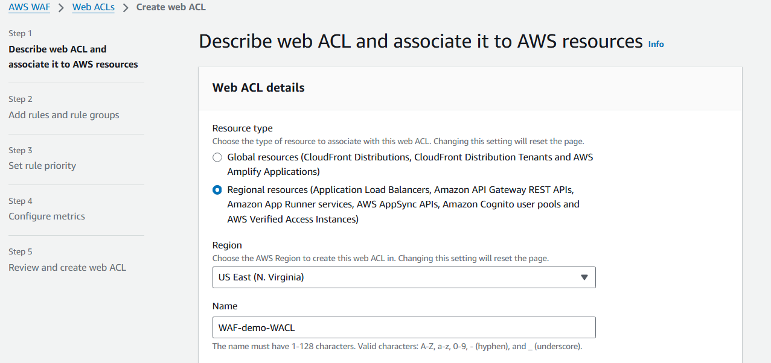
Step 10: Create Web ACL
• Console path: AWS WAF → Web ACLs → Create web ACL
• Explanation: Created a regional Web ACL for Application Load Balancer in us-east-1 region.
• Evidence: 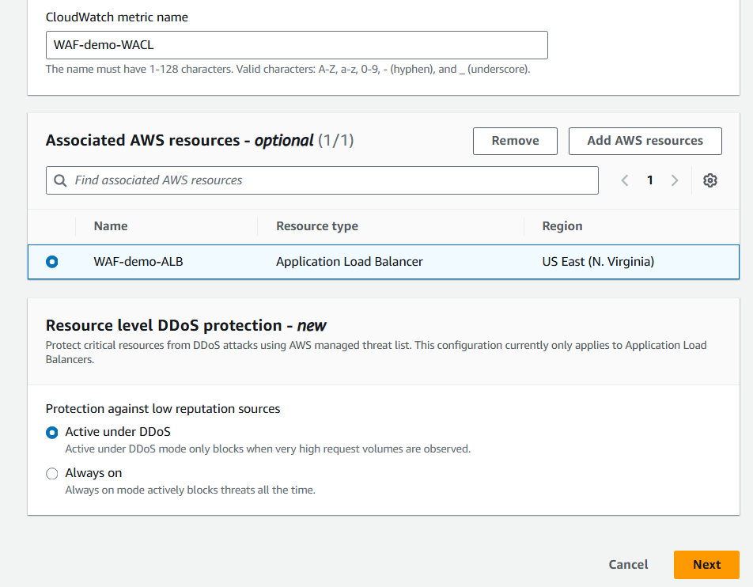
Step 11: Associate Web ACL with ALB
• Console path: AWS WAF → Web ACLs → Associated AWS resources
• Explanation: Associated Web ACL with WAF-demo-ALB to protect incoming traffic.
• Evidence: 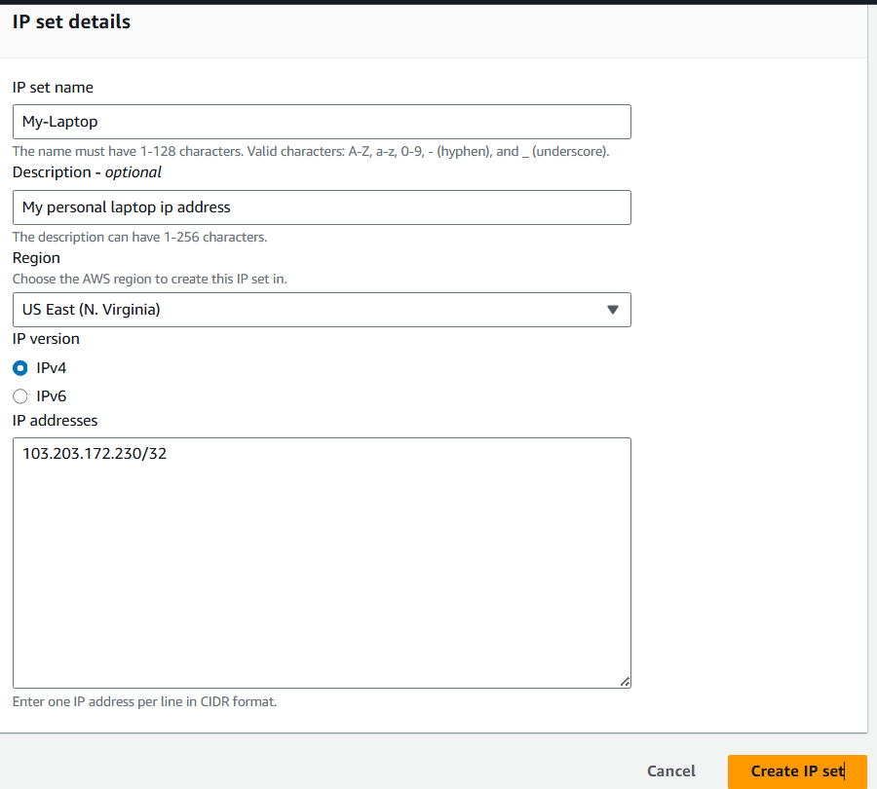
Step 12: Create IP Set
• Console path: AWS WAF → IP sets → Create IP set
• Explanation: Created IP set named My-Laptop containing personal public IP address in /32 format.
• Evidence: 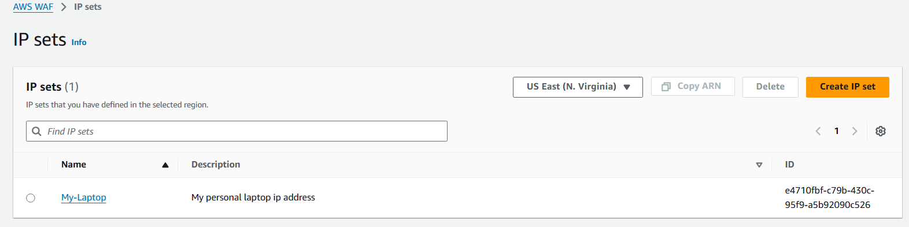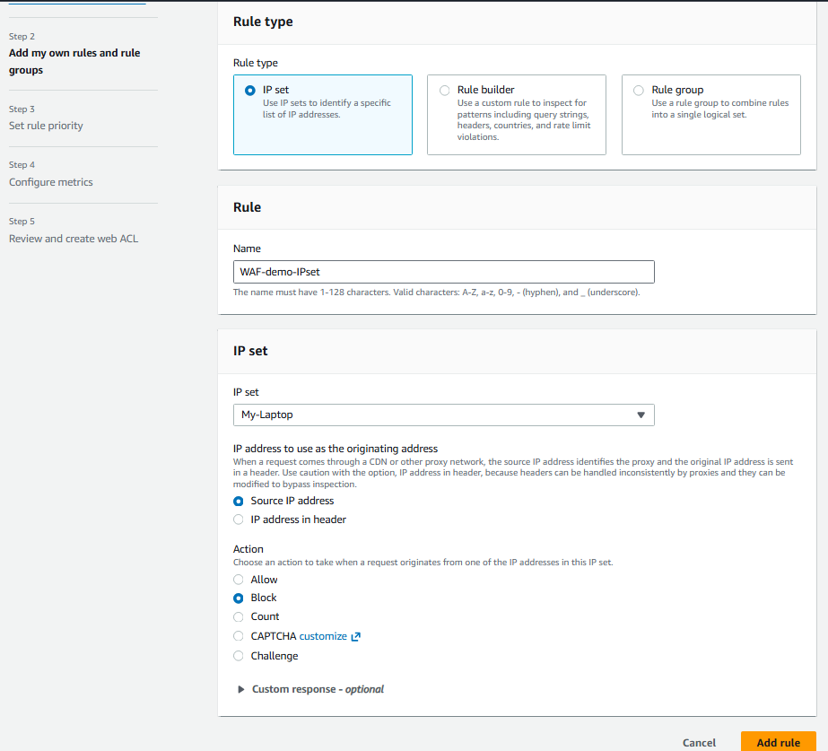
Step 13: Create WAF Rule Using IP Set
• Console path: AWS WAF → Web ACLs → Rules → Add rule
• Explanation: Created rule to inspect source IP and block requests matching IP set.
• Evidence: 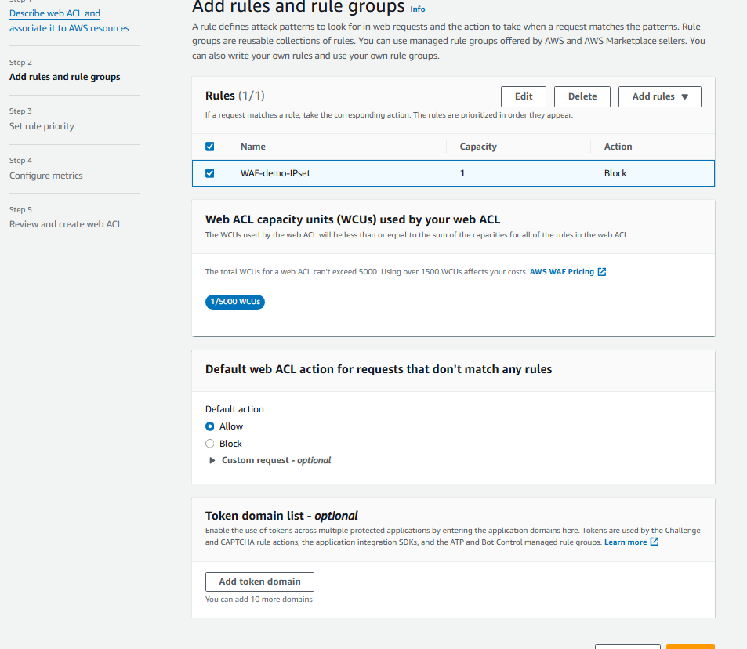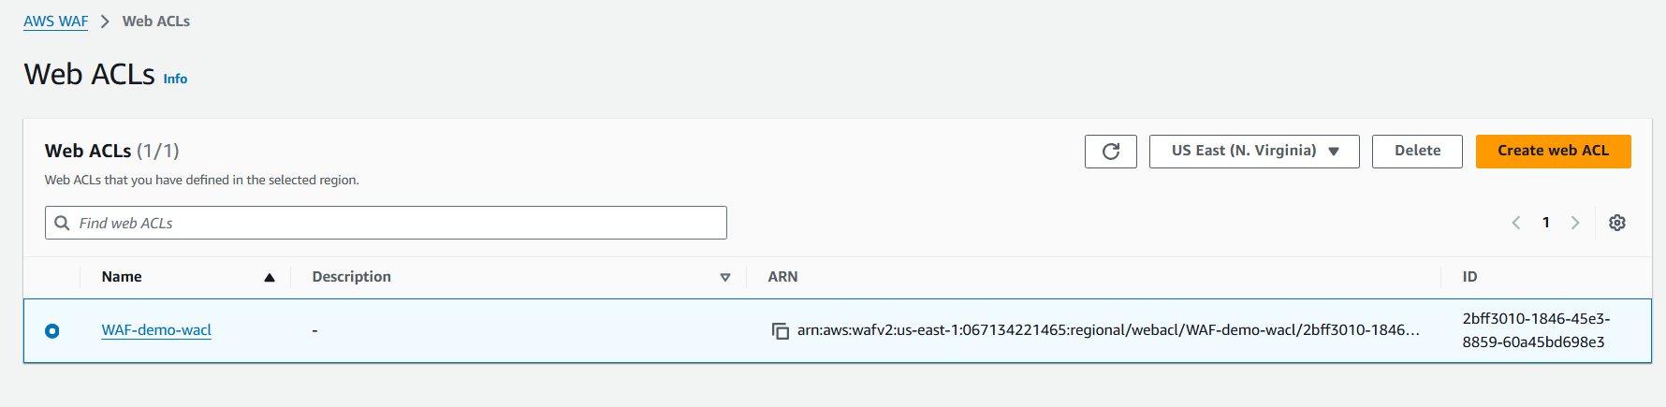
Step 14: Modify Rule Action for Validation
• Console path: AWS WAF → Web ACLs → Rules → Edit rule
• Explanation: Updated rule action from Block to Allow to validate positive access scenario.
• Evidence:
- Validation Steps (Mandatory, With Evidence)
Validation 2: Blocked access from the laptop Ip address
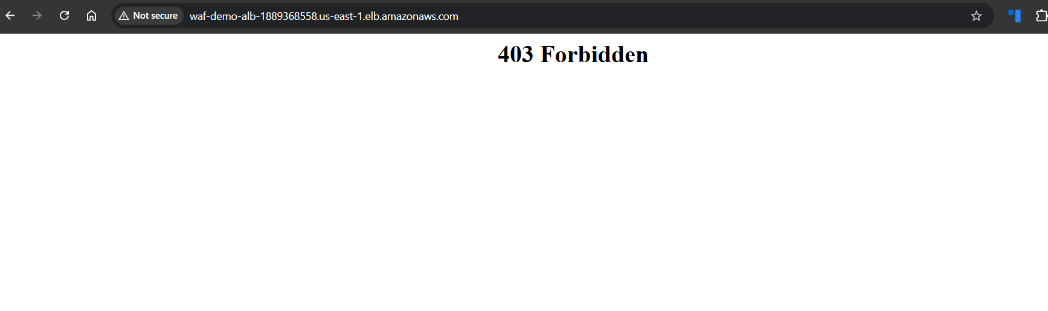
Validation 2: Allowed Access in the action
• Example: After changing WAF rule action to Allow, web page loads successfully showing “Hello from instance1”.
• Evidence: 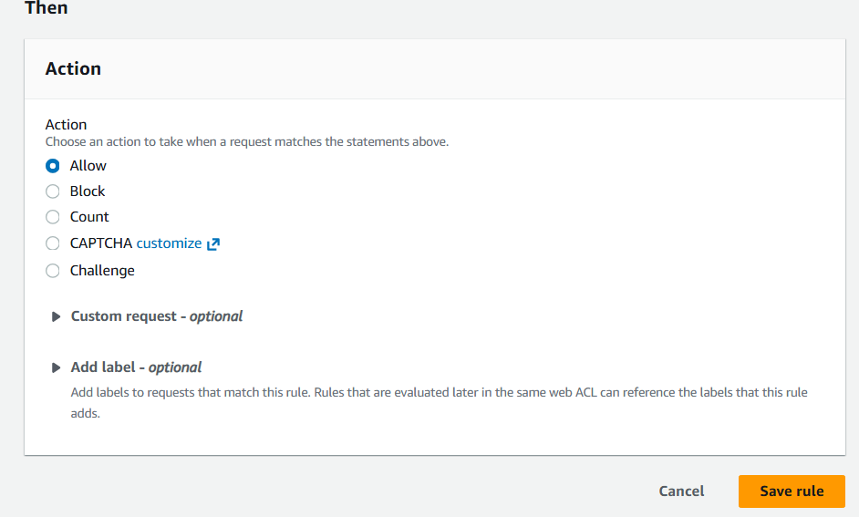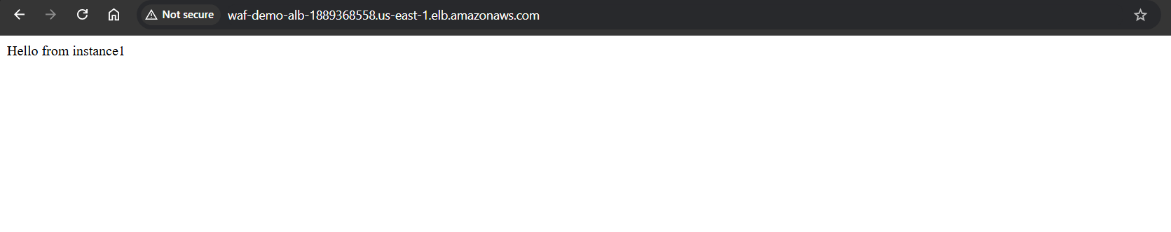
Issues Faced (Optional)
• Initial 403 Forbidden error occurred due to WAF IP set rule blocking client IP.
• Resolved by modifying rule action to Allow for validation.
Conclusion
Successfully deployed an Application Load Balancer protected by AWS WAF using IP-based access control.

